ARBITRARY POWER BOOSTER
IMR Engineering, LLC
Ideas Made Real

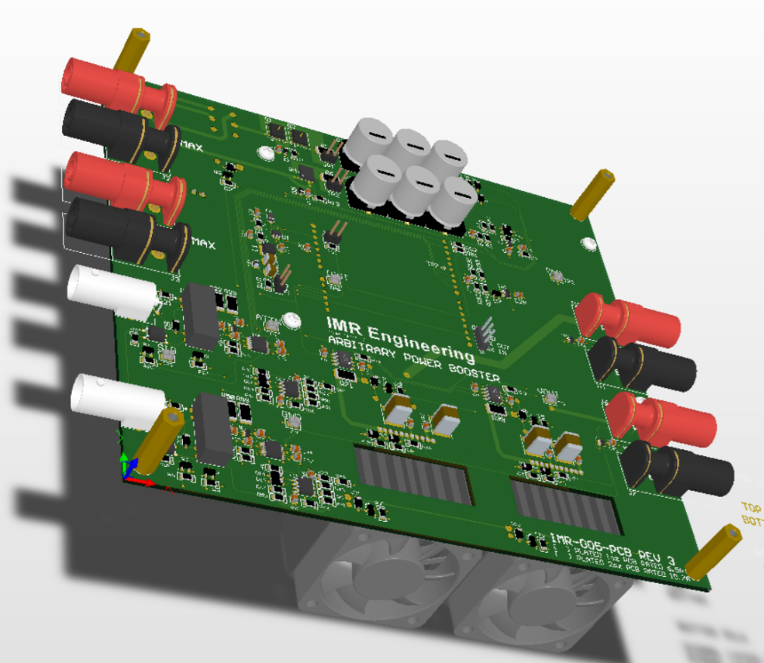

USER MANUAL AND TECHNICAL SPECIFICATION

Principal Engineer: Hab Collector
http://imrengineering.com

Table of Contents
1. INTRODUCTION: 3
1.1 THE PROBLEM: 3
1.2 THE WHAT IF: 3
1.3 THE SOLUTION: 3
2. AT A GLANCE: 4
2.1 FEATURES: 4
2.2 APPLICATIONS: 4
2.3 SIMPLIFIED BLOCK DIAGRAM 5
3. MODES OF OPERATION: 5
3.1 SPLASH SCREEN: 6
3.2 MAIN SCREEN: 6
3.3 CONFIG SCREEN: 7
3.4 SET LIMITS SCREEN: 8
3.5 PHYSICAL CONTROLS: 9
4. TECHNICAL SPECIFICATIONS: 10
4.1 MEASURES 10
4.2 ±VS CURRENT INRUSH MEASURE 11
4.3 INPUT TO OUTPUT 5KHz LOADED AND UNLOADED 12
4.4 Constant Current Mode Enable and Disable 13
4.5 THERMAL PERFORMANCE 13
5. ACKNOWLEDGEMENT 15

DOCUMENT REVISION HISTORY
DATE | DESCRIPTION | EDIT BY
2025-05-29 | Initial draft - Preliminary | HSC
2025-05-30 | Minor formatting. Thermal image clarification. Some additional verbiage for clarity. | HSC
2025-06-03 | Correction to accuracy statement | HSC
2025-06-07 | Amendment to acknowledgement | HSC

INTRODUCTION:

THE PROBLEM:
Your embedded device is part of a much larger system, a system that does not live in isolation, and neither does its power source. It receives power from a parent platform: a drone, a vehicle, modular device, or trailer. While you may have scoped the rails for ripple and noise, what you are really up against is something much harder to simulate and, in fact, more impactful on your embedded DUT.

The power it receives is corrupted; not by the high-frequency harmonic noise you already know how to filter out, but by a deeper, more erratic class of disturbance: harmonic brownouts, surge events, and at times regenerative effects from inductive kickback or back-fed energy. These conditions aren’t artifacts. They are systemic and the reason your device does not operate optimally. This supply rail issue manifests itself in multiple ways:
- Unwanted reset conditions
- Incorrect ADC or DAC measurements or conversions
- Destroyed components or components operating outside specification
- Improper charging or failure to charge
- Etc.
Though it works perfectly on the bench, it fails in-system. The truth is, your benchtop power supply, clean uninterrupted power, is anything but real world. It’s clean, linear, obedient nature in such use-cases only masks the problem. As an engineer it is always your problem to solve, and so you are left with a simple but painful truth: the only place to test and debug these conditions is in the system, in the field, and in person. It cannot be debugged and tested remotely. Or can it?

THE WHAT IF:
Imagine sending your device a: sensor node, data collector, motor controller, or custom SoC board to a client site, a co-developer, or even a third-party integrator. Not waiting for them to integrate, test, and describe what happens under load. From your computer. In your lab. You replicate the exact issue the system imposes on the DUT. And what if you could scale that – not just a single supply rail or source signal, but multiple, and multiple DUT.

Imagine every prototype being powered by a small, intelligent, software-controlled power source that mimics system source issues exactly as they are, on your bench, in your lab, in real time, with real debug and test. Imagine a company standard for supply rail disturbances every embedded device must pass.

Not a luxury - a competitive edge.

THE SOLUTION:
The Arbitrary Power Booster (APB) from IMR Engineering is a precision, high-current, microcontroller-controlled voltage source designed to solve exactly this problem. It acts as a downstream power amplifier, taking in a programmable waveform from an Arbitrary Waveform Generator (AWG) and amplifying that signal into a high-current output — all while regulating the voltage and enforcing programmable current limits in real-time. Why an AWG? Because we are not trying to reinvent the wheel, but solve a real problem in a real way. The AWG is already on your desk. AWGs have the ability to accept and output raw data oscilloscope captures, complex math functions, or scripted sequences. The Arbitrary Power Booster does the rest.

At its core, the Arb Power Booster enables remote, scriptable, and repeatable testing with real load conditions. Its firmware integrates a closed-loop feedback system that monitors output current and enforces soft limits via a firmware-defined PID response. From an engineering perspective, it is a drop-in test solution for hardware developers. From a business perspective, it is a scalable tool for remote debugging, client demos, and iterative remote design. Work done anywhere from everywhere - in this digital age. That is not our future, that is today. That is how we work. The Arb Power Booster adds to that world. I trust you will find it a helpful tool. Ideas Made Real.

AT A GLANCE:

FEATURES:
- Real Time True RMS measure on current and voltage
- PID constant current limit
- Selectable 1MΩ or 50Ω input impedance
- 109.2mm Color LCD Display with 16b color depth
- 480x242 Pixel with Touch LCD HMI
- SSR Fault tolerant Input isolation and protection
- Fault supply rail disconnect
- Device Inrush current limiter
- Over temperature shutdown indicators
- Smart Fan cooling
- uSD user parameter storage
- ARM Cortex M7 200MHz
- Dual independent channel control
- Over Temperature shutdown
- Over Temperature LED indication

APPLICATIONS:
- Augmented Test Equipment
- Remote source simulation
- Supply rail hardening
- Debug Test Develop and Deploy from anywhere

SIMPLIFIED BLOCK DIAGRAM

MODES OF OPERATION:
The Arb Power Booster has a simple, and intuitive 4 screen interface.
- Splash Screen
- Main Screen
- Configuration Screen
- Set Limits Screen

SPLASH SCREEN:


Prompted by POR (Power On Reset) the device is operational with the display of the introduction / splash screen. Following the introduction screen a test of the system parameters to include:
- System ±Supply Rails
- System 3.3V tolerance
- Junction Temperature
is conducted and the Main Screen is launched.

MAIN SCREEN:
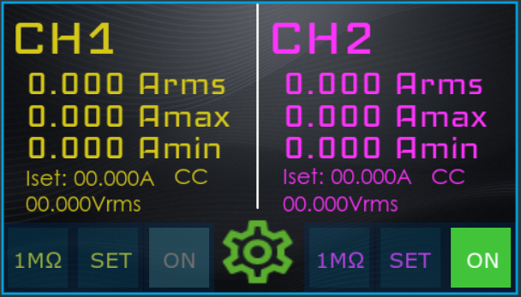

READINGS:
The main screen shows measurement and control for both channels. Output current in RMS, min, and max instantaneous current. If enabled, The set current limit (Iset) and if active, Constant Current (CC) indicator (next to the set current limit). Lastly, the supplied signal in volts RMS. NOTE if the current limit is enabled and the device is in Constant Current mode both the CC indicator and the RMS voltage will flash. The RMS voltage when in CC mode will reflect the actual output value feed to the load and not the input.

CONTROL:
Input Impedance:
The far-left button controls the input impedance. It will read either 1MΩ or 50Ω depending on what it is currently set to. It is a toggle action. This load is the input impedance to the AWG output.
Set:
The middle control. This selection will launch the set limits screen
On:
This is the output on / off control. Note the button only reads “ON”. The background color gives context. When the output is disabled (switched off) it will appear as the channel 1 indicator pictured above. When the output is enabled (switched on) it will appear as the channel 2 indicator. Fan on / off control is firmware driven – on when power dissipated by the output amplifier is greater than 3.5W and truns off 30s following the reduction of this value.
Gear:
The gear is the system status indicator. If green (as shown) it indicates all system parameters are within the specified tolerances. If highlighted by a red box then one or more system parameters are outside the specified tolerances and a system status correction is given. Selecting this control will launch the configuration screen.

CONFIG SCREEN:
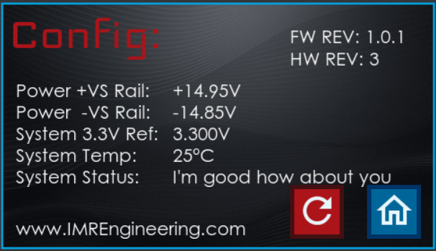

Reset:
This is the red “re-do” button. Selection will cause a device reset – it is disabled in the present revision of firmware – future use TBD.
Home:
Return to the Main Screen

SET LIMITS SCREEN:
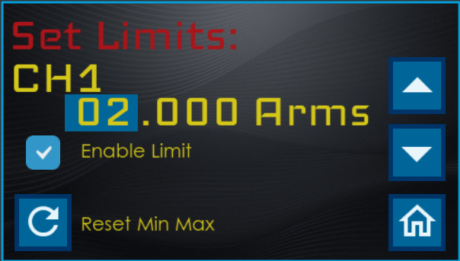

Current Limit:
The current limit is set by selecting the desired Amps, tenths of amps, hundredths of amps, or thousands of amps control. On selection each measure can be incremented up or down via the up / down controls. Note the current limit can not be changed unless Enable Limit is selected.
Enable Limit
Check box, when checked CC mode is enabled via PID control to the current limit
Reset Min Max
Reset the present min and max and return to the Main Screen
Home
Return to Main Screen

PHYSICAL CONTROLS:
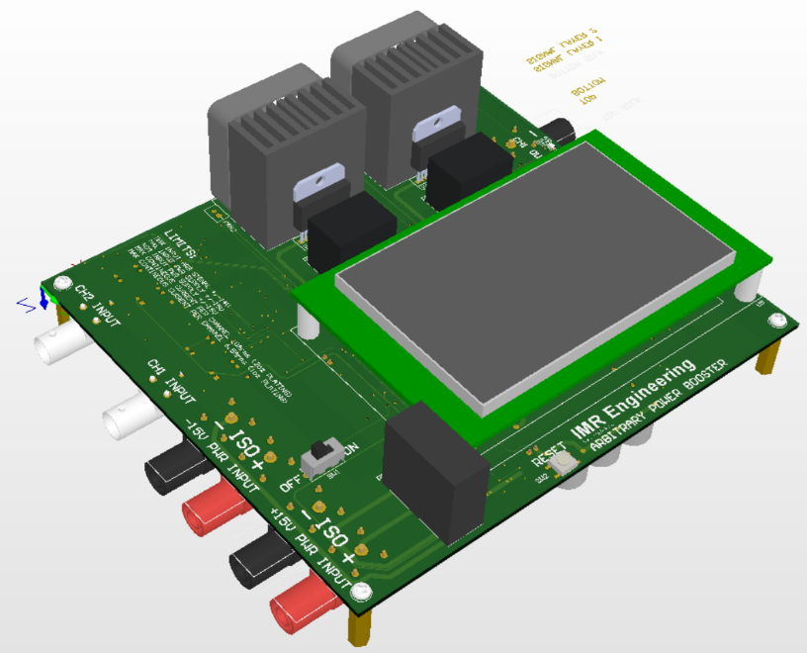
- ON / OFF slide control
- RESET (POR) momentary push tactile

TECHNICAL SPECIFICATIONS:

MEASURES
ABSOLUTE MAX RATINGS
PARAMETER | CONDITION | Min | Typ | Max | UNIT
ENVIRONMENTAL
Operating Temperature |  | -20 |  | 30 | ºC
Storage Temperature |  | -40 |  | 85 | ºC
Relative Humidity | Non-condensing |  |  | 97 | %
SUPPLY RAIL INPUTS
+VS Supply rail | As measured at the APB | 14.5 | 15.0 | 15.5 | V
-VS Supply rail |  | -15.5 | -15.0 | -14.5 | V
INPUT
Input |  | 0 |  | 14.3 | V

OPERATIONAL SPECIFICATIONS
PARAMETER | CONDITION | Min | Typ | Max | UNIT
ENVIRONMENTAL
Temperature |  | -20 |  | 30 | ºC
Relative Humidity | Non-condensing | 0 |  | 95 | %
PHYSICAL DIMENSIONS
Length |  |  | 160.0 |  | mm
Width | Does not include connectors |  | 180.0 |  | mm
Height | Lowest to highest measure |  | 62.0 |  | mm
INPUT
Impedance | 1% of 1MΩ or 50Ω |  |  |  | Ω
Voltage Range |  | -14 |  | 14 | V
Voltage Measure (Reading) | Measured as % Vrms | -0.5 |  | +0.5 | %
OUTPUT
Gain | ¹Non unity gain during CC mode |  | 1 | 1 | V/V
Peak Current | ²Not max power |  |  | 10 | A
Continuous Current | ²Not max power |  |  | 8 | A
Peak Power | Max peak time 5s at Ambient 25°C |  |  | 60 | W
Continuous | Ambient 25°C |  |  | 25 | W
Current Measure (Reading)  Iout = Output Current | ⁴ Iout > 100mArms to limit  ⁴ 30mA < Iout < 100mArms  ⁴ Below 30mArms no statement | -1.0  -10m  NA | NA | +1.0  +10m  NA | %  Arms
POWER CONSUMPTION
Load on -VS supply rail | ³No output loading |  |  | -10 | mA
Load on +VS supply rail | ³No output loading |  |  | 330 | mA
Switch in OFF position |  |  |  | 45 | µA
FREQUENCY AND SAMPLE RATE
Input frequency range |  | 0 |  | 7.812 | KHz
Sample Rate ±VS, Vin, Output Amps |  |  | 64.00 |  | µs
Sample Rate 3.3V & Temperature |  |  | 71.11 |  | µs
CONSTANT CURRENT MODE
Time to 95% convergence CC |  |  |  | 310 | ms
Time to CC mode deactivated | Removal of fault load |  |  | 200 | ms

NOTES:
¹In constant current mode the gain is adjusted in steps via 256 steps from unity to with the first non unity gain decreasing occurring at 0.9961V/V and the last at incremental step at 0.0039V/V
²Output power is limited by the ability to dissipate heat to keep the output amplifiers junction temperature below 160°C. The amplifier’s dissipated power can be approximated by the equation: (Vs nominal – Output Voltage) x Output Current
³±VS nominal supply. Output to both channels switched on. Both fans are on. Input impedance both channels set to 50Ω. There is no output load.
⁴Below 30mArms current what is displayed is the mean not RMS current. Two different ranges for accuracy are given, below and above 100mArms.

±VS CURRENT INRUSH MEASURE

+VS Current Inrush Measure
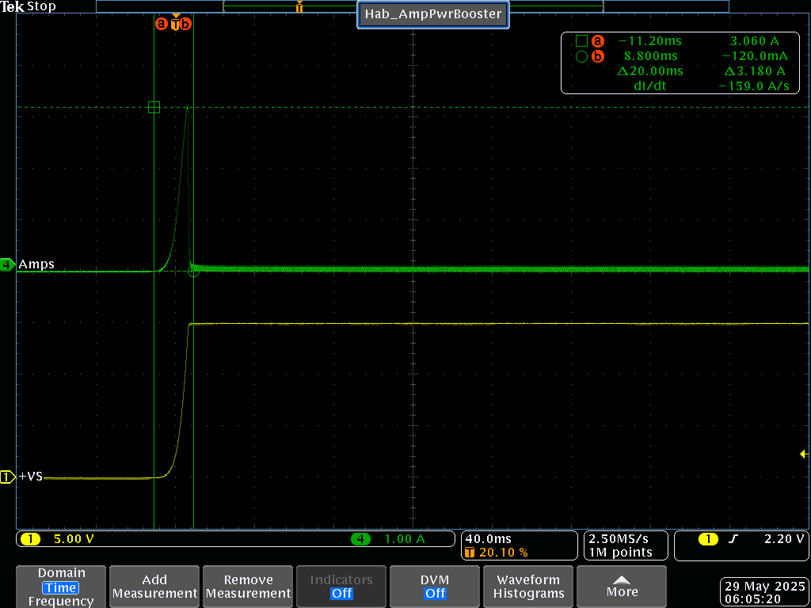
- As measured at POR (Power On Reset)
- NO OUTPUT LOAD

-VS Current Inrush Measure
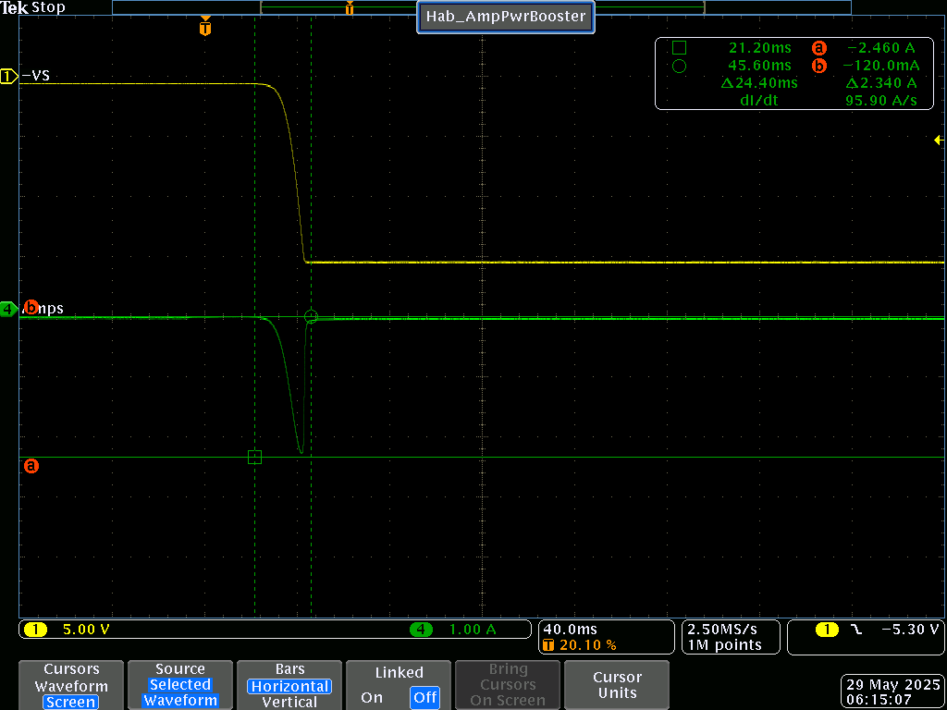
- As measured at POR (Power On Reset)
- NO OUTPUT LOAD

INPUT TO OUTPUT 5KHz LOADED AND UNLOADED

Input Output Response 5KHz No Load
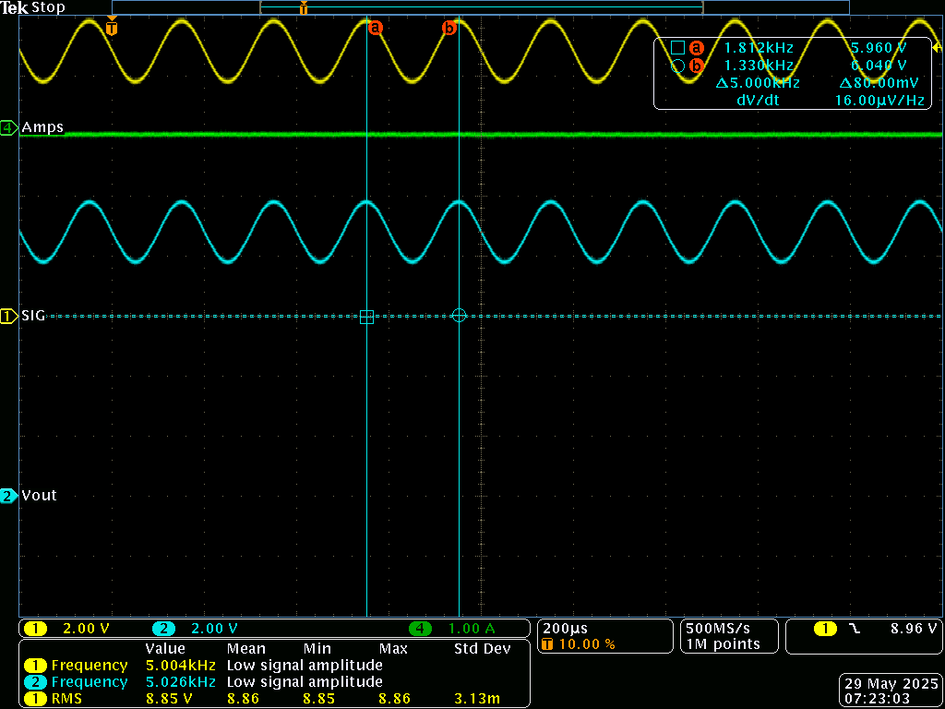
- No measurable change in phase or frequency input to output
- Vin as measured by ARB = 8.93

Input Output Response 5KHz to 8Ω Load
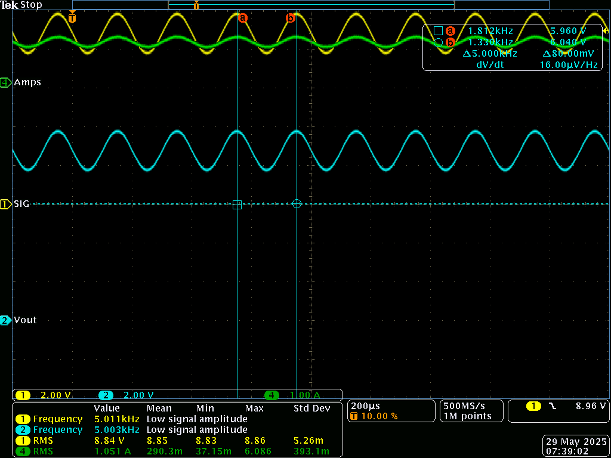
- No measurable change in phase or frequency input to output
- Vin as measured by ARB = 8.92Vrms
- Iout as measured by ARB = 1.061Irms
- Power To Load = 9.29W

Constant Current Mode Enable and Disable
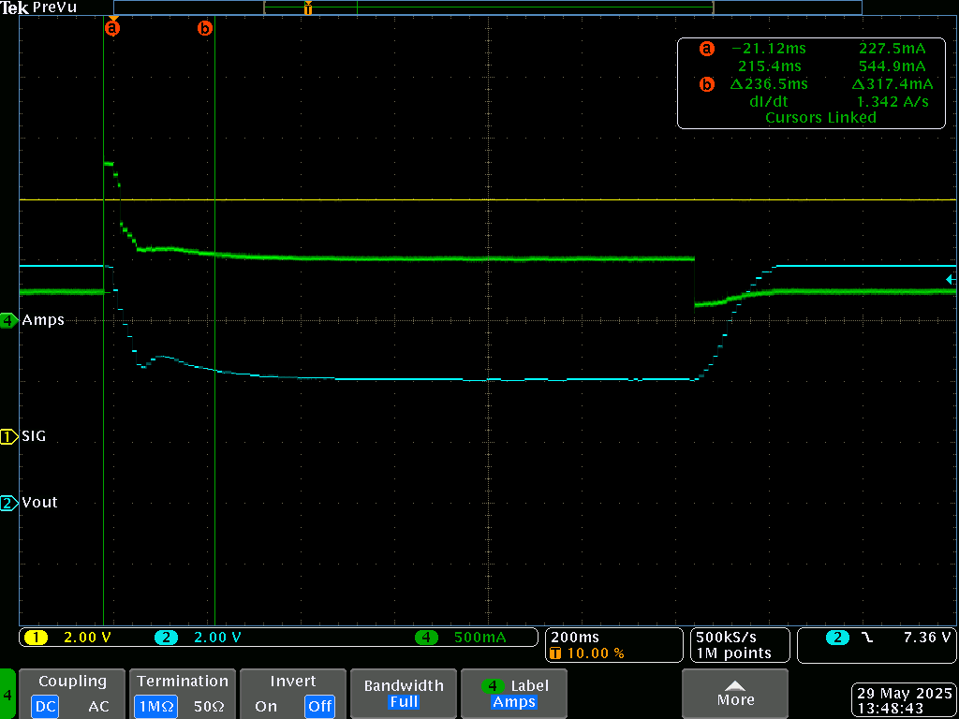
- CC Mode Limit set to 500mA
- Vin 8V
- Vout adjusted based on CC PID to match limit set point of 500mA
- Enable:
  - From a running load of 250mA a fault load of 1A is applied
  - CC mode activates in 236ms (to 95%)
- Disable:
  - From 500mA CC the fault load is reduced to 250mA
  - CC mode disable (150ms)

THERMAL PERFORMANCE

SETUP
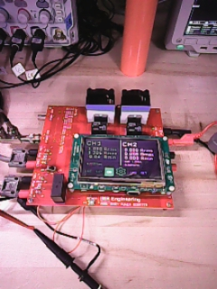
- Connected to 8Ω 100W resistor load not shown

THERMAL IMAGE CHANNEL 1
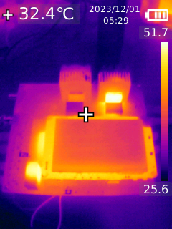
- On Time = 20min
- Output Current = 1.061Arms
- Output Voltage = 8.92Vrms
- PCB PLATED TO 1Oz
- Thermal camera not calibrated, temperature information is incorrect (not nearly that hot), but the image is useful in that you can see heat not being transferred to the heat sink – nothing here was hot to touch.

ACKNOWLEDGEMENT

FAMILY:
To the keeper of me, my beloved wife, I share everything with you. You are my strength in weakness, clarity in uncertainty and applause in victory. I accomplish nothing without your support, nor is anything of worth unless I can share it with you. I love you.

To my daughter Christina, my first born, we have matured and grown together. You are wonderful in spirit, a lover of children, and you put your heart into everything you do. Love is what you do. You are exceptional in so many ways; add to your gifts temperament and discernment and the world is yours.

To my daughter Faith, the Humanitarian, it is clear that you belong to the goodness of this world. You must remember that true greatness is only realized through service and that there are many ways to serve. Therein will be your pursuit – run to catch it. I hope I have shown you how to run.

To my daughter Trinity, the scientist, there is a clarity in the way you speak and think, in your questions and answers. You are to add to the scientific collective. Of the three, you are most like me. Don’t be afraid, nor ashamed of whom you are; accept it, and work hard to be.

To God Almighty, it is you that have made me, and not me myself – thank you for the many blessings, may I be a better servant and steward.

FRIEND:
Special thanks to my friend Walter Varda an absolute Rock Star of analog engineering and an even better person. His input in the earlier stages of the amplifier design process was most helpful to this project. Thank you Walter, you are one of the most generous people I have ever met in my life.

